MLHAS: Machine Learning-based HTTP Adaptive Streaming
for Seamless Video Services in Lossy and Distant Networks

Chaemin Seong, Seongjun Hong, and Kyungshik Lim

School of Computer Science and Engineering, Kyungpook National University
80 Daehakro, Bukgu, Daegu 41566 Korea
Daegu, Korea
coals6751@knu.ac.kr, seong889@gmail.com, kslim@knu.ac.kr

Abstract

The heuristic algorithms to control video bitrates in contemporary HTTP Adaptive Streaming (HAS) implementations could cause frequent rebuffering events in lossy and/or distant network conditions. In this paper, we propose Machine Learning-based HAS (MLHAS) for seamless video services in the fluctuation of dynamic network conditions. MLHAS employs a linear regression model with a supervised learning technique to determine video bandwidth, where the eleven key metrics extracted from the existing HAS metrics are used as input features. Our MLHAS algorithm implements a video bandwidth decision module as a form of an extended HAS client. The module determines an appropriate video bandwidth for the next video segment request, maintaining seamless video streaming in normal network error conditions and reducing the rebuffering frequency in lossy network conditions. The experimental analysis shows the rebuffering frequency of the MLHAS algorithm is much lower than that of the existing HAS algorithm in lossy and/or distant network conditions.

Keywords-machine learning; HTTP adaptive streaming; seamless video streaming; QoE; rebuffering event;

I. Introduction

HTTP Adaptive Streaming (HAS) as adaptive bitrate streaming has recently been introduced to meet the prominent delivery of multimedia content of more than half of the internet traffic [1]. The technique enables HAS implementation to change the video bitrate of partitioned video segments, which are located in web servers, according to dynamic network conditions [2]. Dynamic Adaptive Streaming over HTTP (DASH) was an international standard of HAS in 2012, and the dash.js implementation is a representative implementation of DASH, developed by DASH Industry Forum via JavaScript and compliant browsers [3].

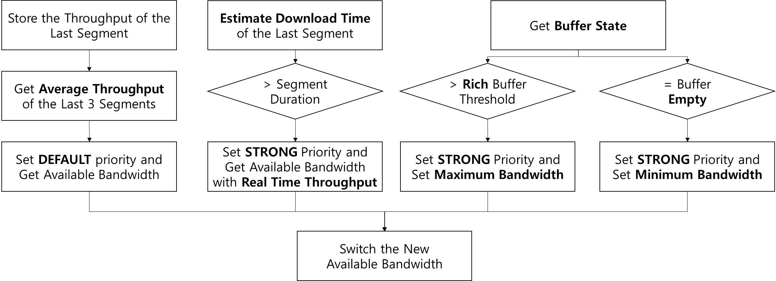
Fig. 1 Adaptation Logic of dash.js Implementation supporting DASH.
To provide the best video streaming service quality, the adaptation logic of the dash.js implementation handles the two metrics of throughput and buffer state when a video segment arrives, as shown in Fig. 1. The throughput-based rules are the primary logic and choose the available video bandwidth based on the throughput measurement and Media Presentation Description (MPD) file, which describes segment information. The default logic of the throughput-based rules utilizes the average throughput of the last three segments, and the second logic utilizes the real time throughput of the last segment when the estimated download time of the segment gets significantly higher than the segment duration. Moreover, the implementation adjusts the video bandwidth to minimum bandwidth if the buffer empty event is found, primarily owing to frequent rebuffering events. The maximum bandwidth is requested if the buffer is able to accept the high bandwidth by the default threshold of the rich buffer length [4].
However, the heuristic algorithms to control video bitrates in contemporary HAS implementations could cause frequent rebuffering events in dynamic lossy and/or distant network conditions. Further, other than the throughput and buffer state, the HAS metrics have several parameters such as download time from HTTP request start to HTTP response start, and latency time from HTTP response start to HTTP response end. Moreover, in the video streaming service, the perceived quality for end users and video content information are measured in major metrics such as rebuffering frequency, rebuffering duration, video segment size, and current bandwidth of video segment [5]. Therefore, to provide improved quality of the video streaming service in any network conditions, the HAS implementation should certainly define the relation between the video bandwidth and several metrics, such as, Quality of Service (QoS), Quality of Experience (QoE), and video content information, thereby operating well in the variation of the network conditions.
In this paper, we propose Machine Learning-based HAS (MLHAS) for seamless video services through complex HAS metrics. MLHAS employs a linear regression model with a supervised learning technique to determine video bandwidth, where the eleven key metrics extracted from the existing HAS metrics are used as input features for training in MLHAS server. Our algorithm is implemented in an extended HAS client as a video bandwidth decision module to request an appropriate video bandwidth for the next video segment. With the machine learning concept, the MLHAS could provide seamless video streaming in lossy and/or distant networks better than the contemporary HAS implementations.
The remainder of this paper is organized as follows: Section 2 introduces related work of machine learning-based adaptive streaming. In Section 3, we describe the MLHAS approach and system to determine the relation between HAS metrics and video bandwidth. Section 4 discusses the results of the system performance and we conclude in Section 5.

II. Related Work

Many heuristic algorithms of adaptive bitrate streaming have recently been proposed to improve the quality of HTTP-based video streaming. These current algorithms fit specific network configurations. Therefore, in order to enhance perceived quality for the end user despite the fluctuation of dynamic network conditions, research interest in machine learning-based adaptive streaming has increased [6-9].
TABLE I MLHAS METRICS FOR INPUT FEATURES

Metrics | Components | Content
QoS | real throughput [Kbps] | Real throughput of a video segment
QoS | average throughput  [Kbps] | Average throughput of the last 3 video segments
QoS | latency time  [ms] | Delay time from HTTP request start time to end time
QoS | download time [ms] | Delay time from HTTP response start time to end time
QoS | network variation [true/false] | dash.js rule using real throughput when network state deteriorates
QoS | buffer length  [s] | Playout duration for which media data of all active media components is available to start
QoE | dropped frames [integer number] | The number of video frames dropped by interruption in HTML video object
QoE | rebuffering frequency  [integer number] | Frequency of rebuffering event caused by less than half a second of buffer length
QoE | rebuffering duration  [ms] | Duration time when rebuffering event occurs
Video Content | file size  [Kbytes] | File size of a video segment
Video Content | current video bandwidth  [Kbps] | Bandwidth of the video segment that is currently being rendered by the player

Frequency adjusted Q-learning (FAQ-learning) utilizes reinforcement learning as a machine learning technique. FAQ-learning has the advantage of good operation with a reward calculation that quantifies feedback of the quality adaptation, regardless of limited knowledge about the network environments. However, the algorithm performance should be compared with DASH, as well as Microsoft IIS Smooth Streaming (MSS), and be evaluated in various network conditions with lossy and/or distant links [8]. Moreover, the conventional HAS algorithms handle several HAS metrics, such as available bandwidth, buffer filling state, and estimated download time. To address the use of the narrow range of input features, MLHAS evaluates many different metrics related to the network conditions such as bandwidth, RTT, and buffer size [9]. MLHAS exploits the wide range of useful network-related features to train a bitrate classification model.
These QoS metrics have been used to study the performance of online services and networked elements. Nevertheless, the metrics do not capture the actual perceived quality of HAS service for the end user [5][10][11]. Therefore, the quality enhancement of the HAS service is derived from QoS metrics such as hardware conditions and network conditions, as well as QoE and video content metrics, such as rebuffering frequency, rebuffering duration, current video quality, and file size.

III. MLHAS Approach and System
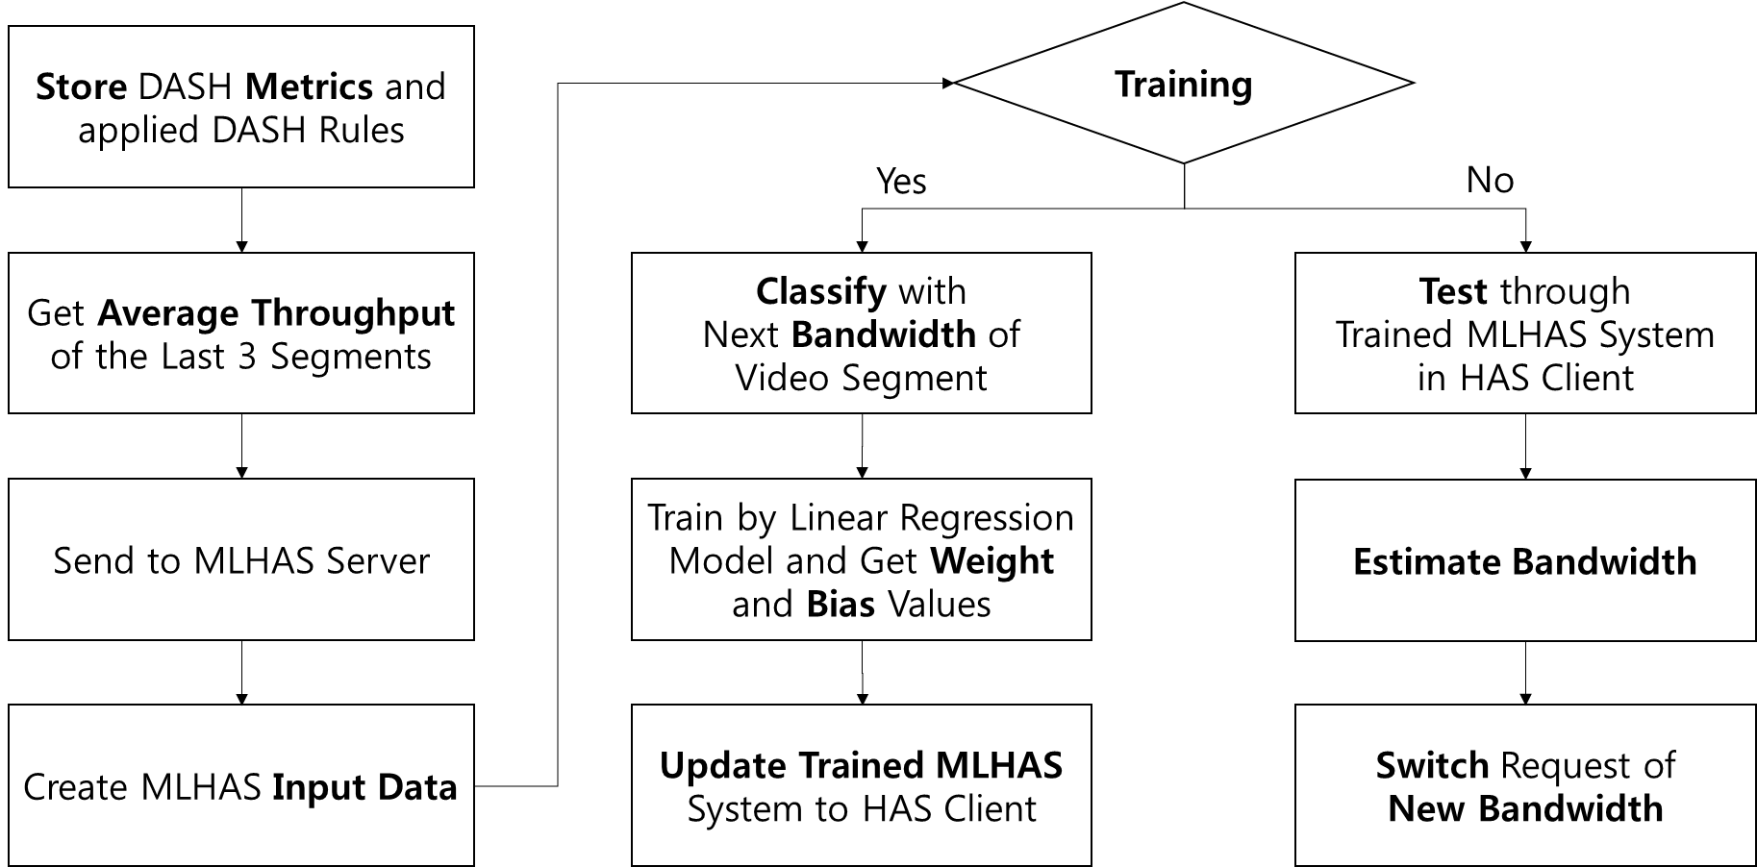
Fig. 2 Logical System Flow Chart for Training/Testing of MLHAS.
A. MLHAS Approach

The MLHAS goal is basically to guarantee seamless video streaming in the fluctuation of dynamic network conditions. Another goal is to get high throughput and low download time such that a rebuffering event is not generated for the end user. The rebuffering event is determined when the current buffer length is less than half a second in the dash.js implementation. To satisfy these goals, MLHAS uses variable HAS metrics for input features as shown in Table I such as QoS, QoE and content metrics, which are extracted from the metrics of the dash.js implementation (version 2.2.0) [11].
First, the QoS metrics include network and hardware conditions; real throughput of video segments, average throughput of last three video segments, latency time from HTTP request start time to end time, download time from HTTP response start time to end time, boolean value of network variation managed by a dash.js rule with real throughput when the network state deteriorates, buffer length, and the number of dropped frames detected in the HTML video object. Second, the QoE metrics are cumulated rebuffering frequency and duration. Finally, the video content metrics are the file size and current video bandwidth for each video segment.
Based on these metrics, in Fig. 2, we classify the ith stored metrics with i+1th bandwidth of the video segment in order to train using a linear regression model in the MLHAS server [12]. After training, when the user requests video streaming service, the MLHAS acquires the weight and bias values of the linear regression model, and the trained system is sent to the client to estimate the video bandwidth for the next video segment through the local websocket with the dash.js implementation.
B. MLHAS System

MLHAS system architecture is implemented with TensorFlow, an open source software library, and consists of four components as shown in Fig. 3 [13]. The HAS Server contains partitioned video segments of multiple video bitrates and provides HTTP-based video streaming to the HAS client. The MLHAS Server trains the linear regression model with a class label, which is the video bandwidth of the next video segment, and log data, which is included with MLHAS metrics for input features. The Extended HAS Client requests HAS video streaming and measures the HAS metrics for communication Trained MLHAS. A video bandwidth decision module of Trained MLHAS is implemented in the client and is transmitted with weight and bias values, and the linear regression model from the MLHAS Server. The module analyzes the new log data related to the quality of the video streaming service, which is transmitted from Extended HAS Client, and then determines a new video bandwidth for the next video segment through the model.
Additionally, the HAS dataset is used a general dataset with about 10 minutes and Big Buck Bunny animation [14]. The animation has 20 representation levels with several bitrates from 50 Kbps to 8 Mbps and resolutions up to 1920 and 1080 respectively, and includes 300 video segments with 2 seconds duration of each video segment. Moreover, network environments between the server and client have a 40 Mbps bandwidth link with loss rates from 0.01% to 1%, and delay time from 0 milliseconds to 80 milliseconds using tc command of Linux system.
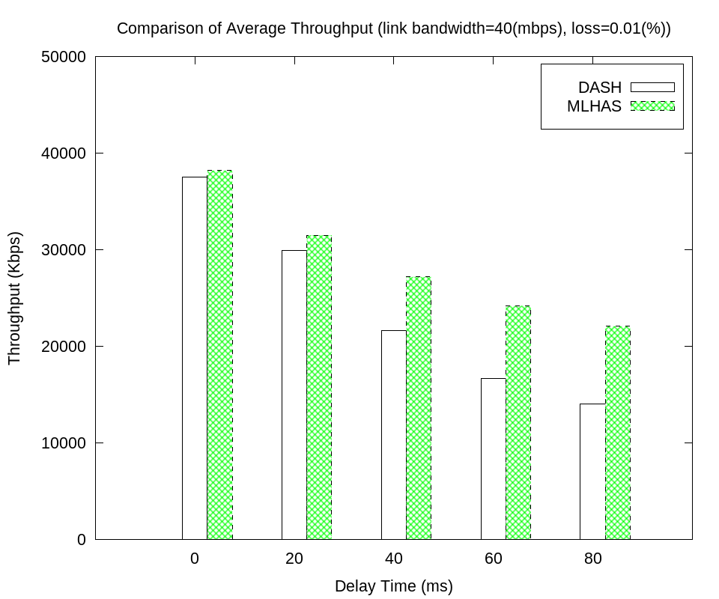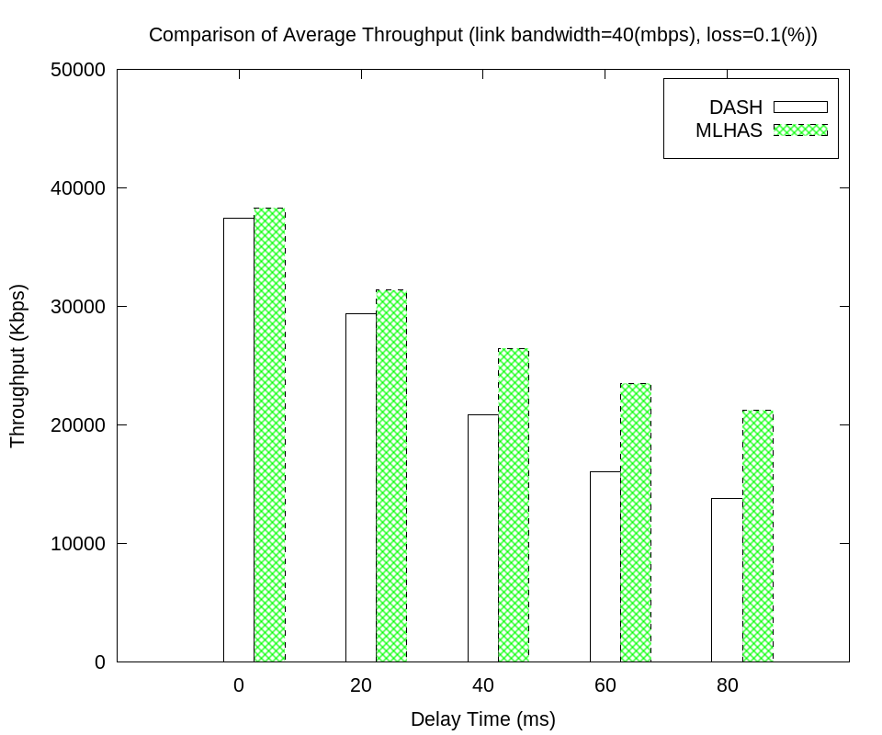
Fig. 5 Comparison of Average Throughput in Weak Lossy Network.

IV. Results

For good prediction of incoming video bandwidth, our proposed algorithm with supervised learning identifies mapping from input features to an output class; the former is QoS, QoE, and video content metrics, and the latter is the video bandwidth for the next video segment in the MLHAS system architecture. The linear regression model of MLHAS updates weight and bias values by a gradient descent algorithm, which is a first-order iterative optimization algorithm utilized to find a local minimum. We train MLHAS to determine the video bandwidth for the next video segment with the collected log data of 150 video playbacks over all network environments, and a 0.001 learning rate. The process is iterated during 1000 training epochs because the mean squared error, which is a cost function in our system, is minimized with 0.056 as shown in Fig. 4. The test dataset with one video playback likewise achieves the same declining cost error trend.
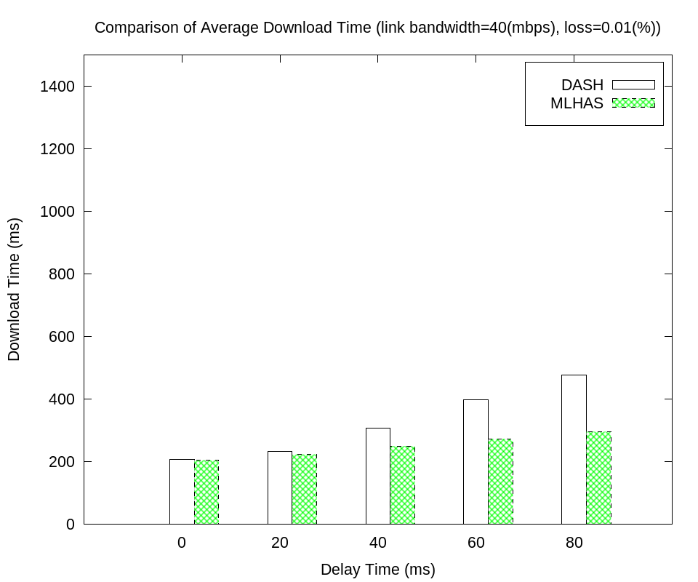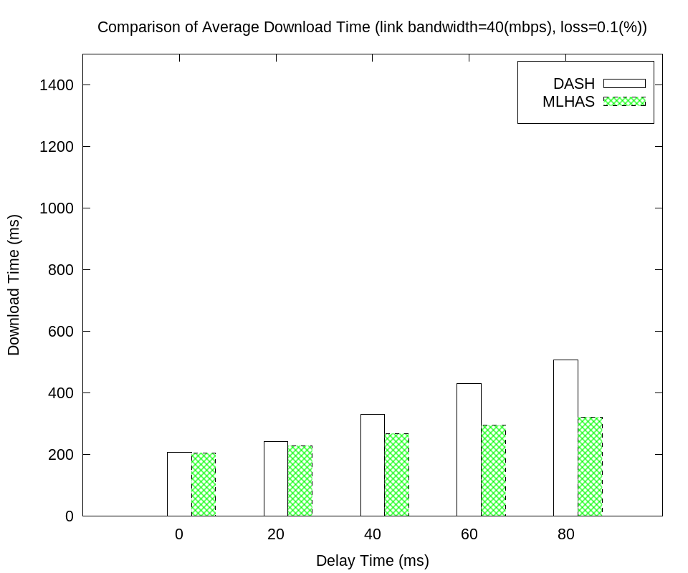
Fig. 6 Comparison of Average Download Time in Weak Lossy Network.

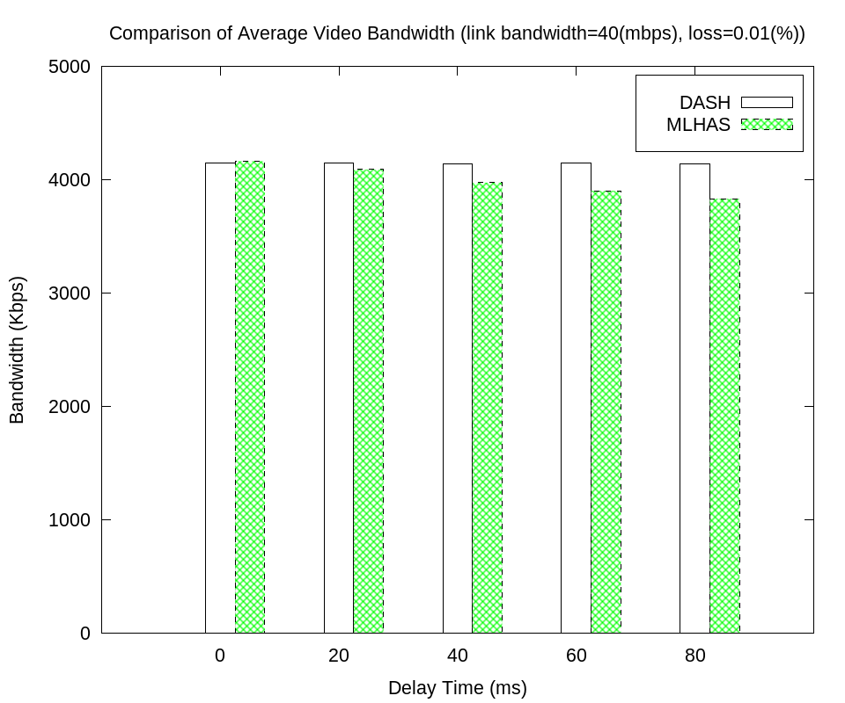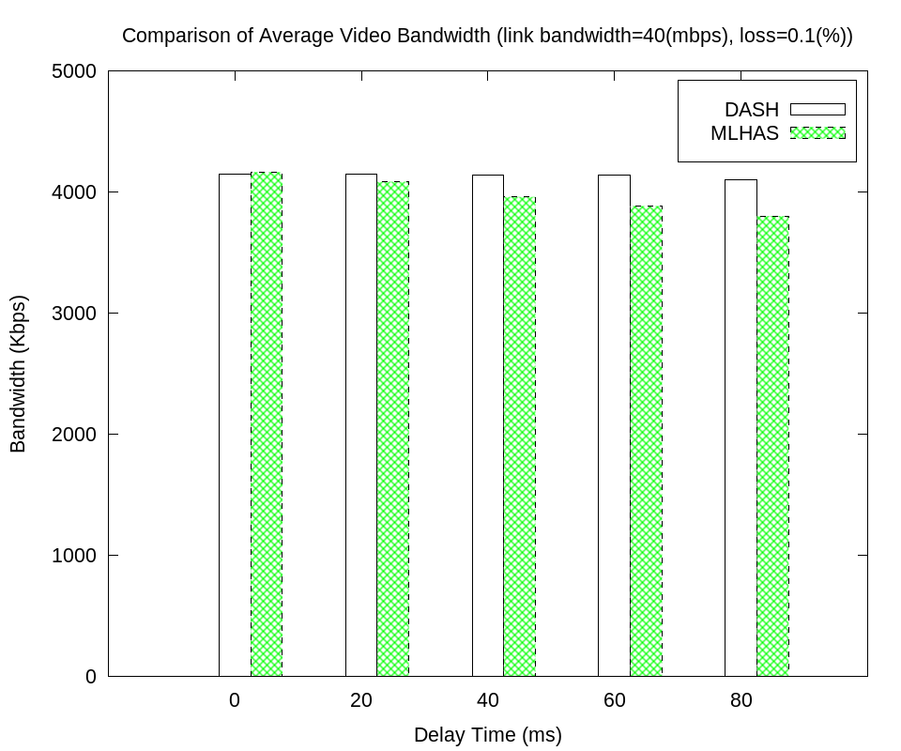
Fig. 7 Comparison of Average Video Bandwidth in Weak Lossy Network.

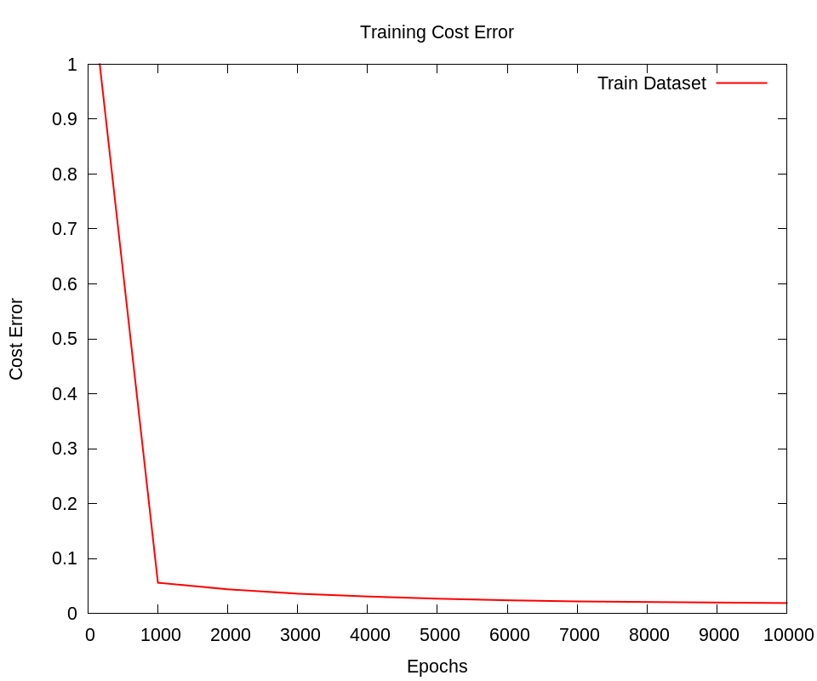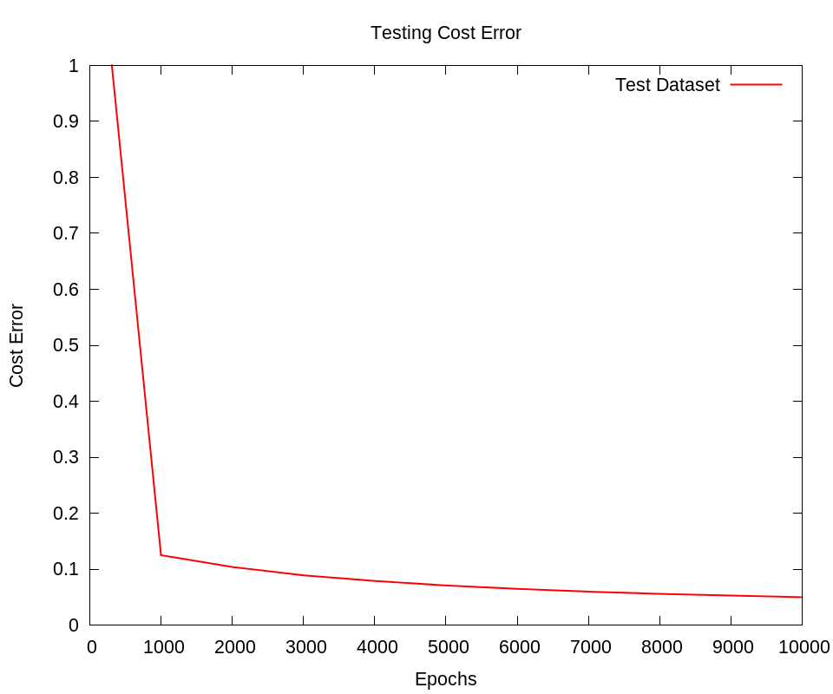
Fig. 4 Cost Error of MLHAS Training and Testing.
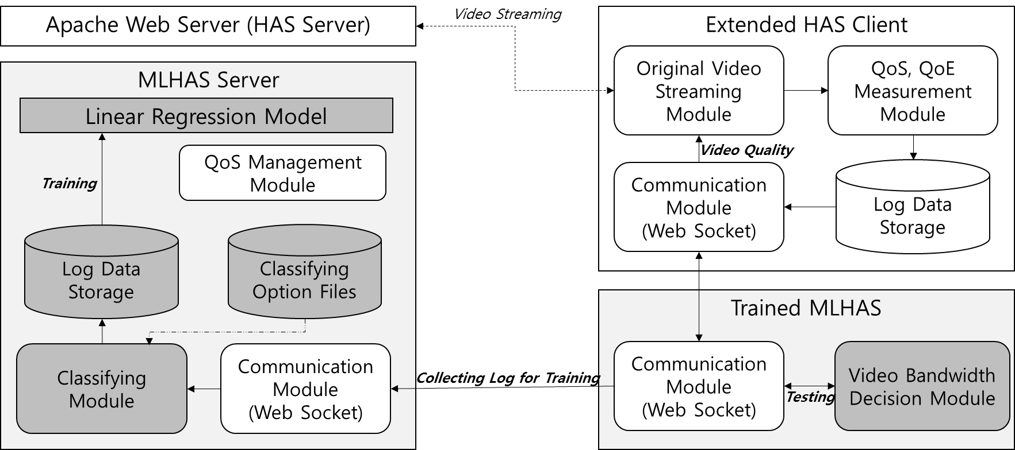
Fig. 3 MLHAS System Architecture.
In Fig. 5, the pre-trained MLHAS provides the high video quality of the HAS service for the end user because the average throughput of MLHAS is increased, up to a double value in the high delay time of 100 milliseconds, in weak lossy network environments with 0.01% and 0.1% loss rate. Additionally, in Fig. 6, the increased range of the average download time, in our system, is lower than DASH, and the download time of MLHAS is maintained at approximately 200 milliseconds when the delay time of the network environment increases. Thus, MLHAS is superior to DASH in the utilization of the available link bandwidth, regardless of the similarity between the average video bandwidths as shown in Fig. 7. Additionally, since the rebuffering event does not occur in both systems, our system maintains seamless video streaming.
In Fig. 8, in strong lossy network environments with 1% loss rate, MLHAS shows a better reduction of the average rebuffering frequency over DASH, particularly in the especially distant links of 40 milliseconds to 80 milliseconds. Thus, MLHAS improves the perceived quality for the end user in the lossy network by decreasing the average video bandwidth and throughput. In a low delay time with 0 milliseconds and 20 milliseconds, the throughput of MLHAS is similar to that of DASH because frequent rebuffering does not occur. Therefore, MLHAS can predict video bandwidth for seamless video services and achieve good performance for the end user because the perceived quality should be guaranteed without reference to lossy and/or distant links.
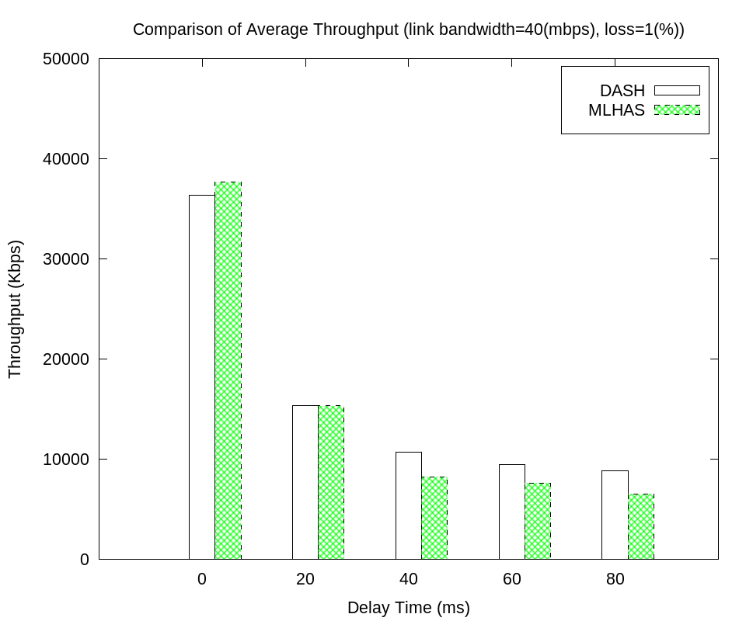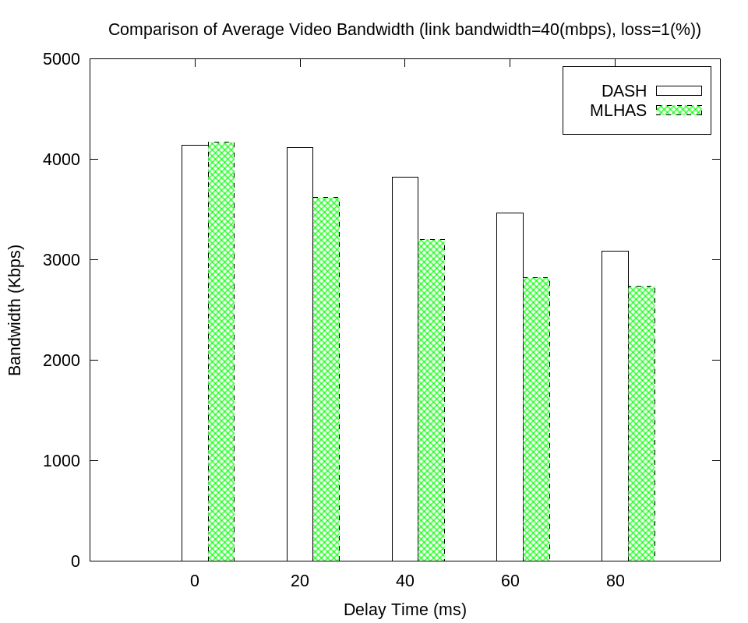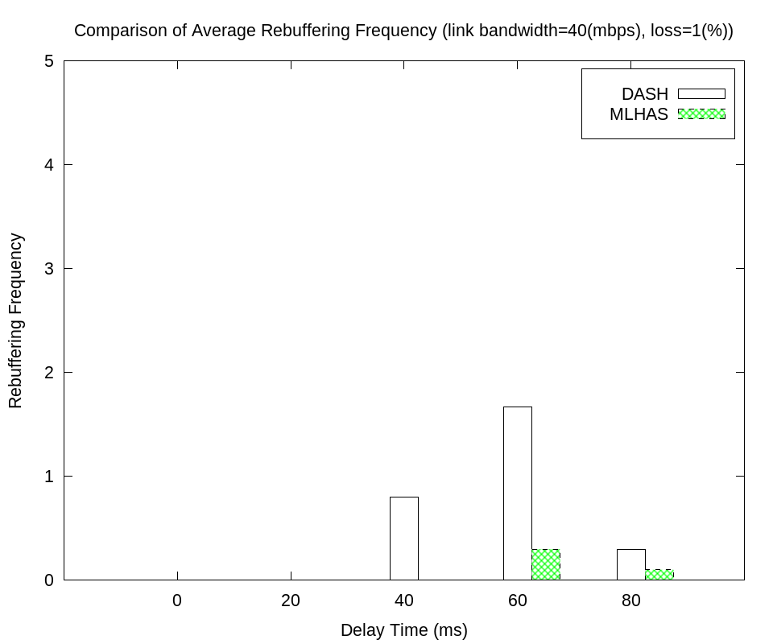
Fig. 8 Comparison of Average Throughput, Average Video Bandwidth, and Average Rebuffering Frequency in Strong Lossy Network.

V. Conclusion

In this paper, we applicate machine learning to conventional HAS (MLHAS) to provide seamless video streaming in lossy and/or distant networks. Our algorithm employs a linear regression model to determine an appropriate video bandwidth with several HAS metrics such as QoS, QoE, and video content metrics, whereas the heuristic algorithms of existing HAS implementations have utilized only throughput and buffer state. We acquire weight and bias values of the linear regression model between HAS metrics, which are input features, and video bandwidth, which is the class label, to determine the video bandwidth of the next video segment.
Based on this training process, the trained MLHAS requests a new video bandwidth from the HAS implementation through the local websocket of the HTML elements. Through these mechanisms, MLHAS maintains seamless video streaming under weak lossy and/or distant networks when the rebuffering event is not generated in both the existing system and our system. Moreover, experimental analysis shows the throughput of our algorithm to be much higher than that of the existing HAS algorithm. Additionally, the download time of our algorithm is much lower than that of the existing HAS algorithm. Further, MLHAS guarantees seamless video streaming, in strong lossy and/or distant network conditions, by achieving a lower rebuffering frequency than DASH.

Acknowledgment

This research was supported by the MSIP(Ministry of Science, ICT and Future Planning), Korea, under the National program for Excellence in Software supervised by the IITP(Institute for Information& communications Technology Promotion)
References

[1] Sandivine Global Intenet Phenomena Report, http://www.sandvine.
com/news/global_broadband_trends.asp (last access: Oct., 2016).
[2] T. Stockhammer, “Dynamic Adaptive Streaming over HTTP: Standards and Design Principles,” Proceedings of second annual ACM conference on Multimedia systems, pp. 133-144, 2011.
[3] DASH Industry Forum, http://dashif.org/reference/players/
javascript/v2.2.0/samples/dash-if-reference-player/index.html (last access: Oct., 2016).
[4] DASH Industry Forum, https://github.com/Dash-Industry-Forum/
dash.js/wiki/ABR-Logic (last access: Oct., 2016).
[5] M. Seufert, S. Egger, M. Slanina, T. Zinner, T. Hoßfeld and P. Tran-Gia, “A Survey on Quality of Experience of HTTP Adaptive Streaming,” IEEE Communications Surveys & Tutorials, vol. 17, no. 1, pp. 469-492, 2015.
[6] V. Martín, J. Cabrera, and N. García, “Q-learning based Control Algorithm for HTTP Adaptive Streaming,” 2015 Visual Communications and Image Processing, pp. 1-4, 2015.
[7] J. van der Hooft, S. Petrangeli, M. Claeys, J. Famaey, and F. De Turck, “A Learning-based Algorithm for Improved Bandwidth -awareness of Adaptive Streaming Clients,” 2015 IFIP/IEEE International Symposium on Integrated Network Management, pp. 131-138, 2015.
[8] M. Claeys, S. Latré, J. Famaey, T. Wu, W. Van Leekwijck, and F. De Turck, “Design and Optimisation of a (FA)Q-Learning-based HTTP Adaptive Streaming Client,” Connection Science, vol. 26, no. 1, pp. 25-43, 2014.
[9] Y. L. Chien, K. C. J. Lin, and M. S. Chen, “Machine Learning Based Rate Adaptation with Elastic Feature Selection for HTTP-based Streaming,” IEEE International Conference on Multimedia and Expo, pp. 1-6, 2015.
[10] P. Juluri, V. Tamarapalli, and D. Medhi, “Measurement of Quality of Experience of Video-on-Demand Services: A Survey,” IEEE Communications Surveys & Tutorials, vol. 18, no. 1, pp. 401-418, 2016.
[11] DASH Industry Forum, http://dashif.org/wp-content/uploads/2016/
10/ProposedMediaMetricsforSegmentedMediaDelivery-r12.pdf
(last access: Oct., 2016).
[12] T. T. T. Nguyen, and G. Armitage, “A Survey of Techniques for Internet Traffic Classification using Machine Learning,” IEEE Communications Surveys & Tutorials, vol. 10, no. 4, pp. 56-76, 2008.
[13] TensorFlow, https://www.tensorflow.org/ (last access: Oct., 2016).
[14] S. Lederer, C. Müller and C. Timmerer, “Dynamic adaptive streaming over HTTP dataset,” Proceedings of 3rd Multimedia Systems Conference, pp. 89-94, 2012.

